DIRECTORATE OF INFORMATION & COMMUNICATION
Press Release No: 04/2022
Date: Tuesday, 24 May, 2022
Venue: Ouagadougou, Burkina Faso

AFRICAN UNION CIEFFA HOSTS A ROUND TABLE DISCUSSION TO CELEBRATE AFRICA DAY
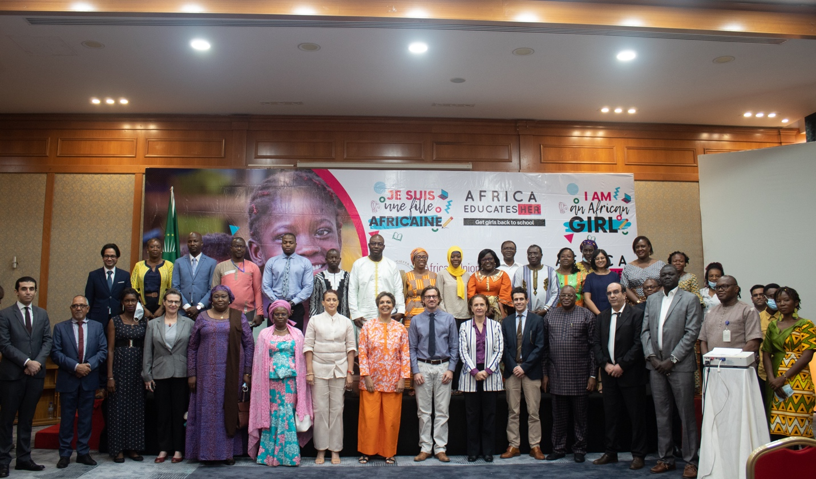
Group picture of the participants at the Africa Day Celebration organized by the African Union CIEFFA
The African Union International Center for Girls' and Women's Education in Africa (AU/CIEFFA) organized a round-table discussion for Africa Day on the theme: "Promoting the retention of Girls in School through School Feeding Programs with the support of Women in Agribusiness” in Ouagadougou, Burkina Faso on 24th May 2022.

This event brought together members of the diplomatic corps, development partners, young women in agribusiness, teachers, students and other stakeholders in the education sector to discuss the impact of school feeding programs on retention of girls in schools and how young women entrepreneurs in the agribusiness sector can support school feeding programs.

Dr. Rita Bissoonauth, Head of Mission of the African Union CIEFFA, in her welcome remarks, stressed that Africa Day is an opportunity to reflect on the progress Africa has made since the founding of the African Union, formerly OAU, as well as a moment to think deeper on the impact of school feeding programs on girls’ and women’s education.

“Today’s panel discussion is an opportunity to showcase the commitment of women entrepreneurs in agribusiness to invest in and help provide school food of quality and quantity to our children at school, especially to vulnerable girls,” she said.

In her keynote remarks, Mrs. Sandra Lattouf, Country Director, UNICEF, Burkina Faso, stressed on the importance of an integrated and coordinated approach to addressing the food and nutritional crisis faced by families and children in Burkina Faso. She also took the opportunity to call on women in agribusiness, technical and financial partners as well as non-governmental organizations to renew their commitment to school feeding programs.

Mr. Antoine Renard, Country Director, World Food Program (WFP) in Burkina Faso, highlighted how school meals had increased the completion rates, with a 12% increase in girls' access to education in 32 sub-Saharan countries through school meals and take-home rations and a 54% increase of women involved in farmers' organizations contracted by the WFP at the local level between 2021 and 2022. He also outlined other studies showing the positive correlation between school feeding programs, school enrollment and attendance rates with improved nutritional status, health and cognitive development of learners.
Ms. Simone Yankey, Senior Policy Officer African Union CIEFFA, moderated a round table discussion, where women entrepreneurs in agribusiness shared their experiences and challenges encountered in contributing to school feeding programs. The other panelists included a teacher, a student and a representative from Plan International, who all underlined the importance on how far a school meal a day can contribute to girls being able to attend a whole day of schooling, thus increasing their chances of completing their education.
In her closing remarks, Mrs. Barbara Manzi, United Nations Resident Coordinator in Burkina Faso, stressed the importance of ensuring quality nutrition and education for girls by recalling the promises made though the 2030 Sustainable Development Goals and the African Union’s Agenda 2063.

African Union International Centre for Girls’ and Women’s Education in Africa

African Union CIEFFA is a specialized institution of the African Union under the Department of Education, Science, Technology and Innovation. The Centre aims to promote girls’ and women’s education with a view towards their full participation in the eradication of poverty and the edification of a peaceful world for sustainable human development. http://cieffa.au.int.

For further information please contact:

Ms. Anoziva Marindire, Communications Officer | African Union International Center for Girls & Women’s Education in Africa | African Union Commission | Tel: +226 25 37 61 55 | E-mail: MarindireA@african-union.org | Ouagadougou, Burkina Faso

Ms. Faith Adhiambo, Communications Officer- Agenda 2063 Information and Communication Directorate | African Union Commission | Tel: +251 115 517 700 | E-mail: ochiengj@african-union.org | Addis Ababa, Ethiopia

Information and Communication Directorate, African Union Commission I E-mail: DIC@africa-union.org
Web: www.au.int | Addis Ababa, Ethiopia | Follow Us: Facebook | Twitter | Instagram | YouTube

